**How Angular App gets Loaded and Started:**

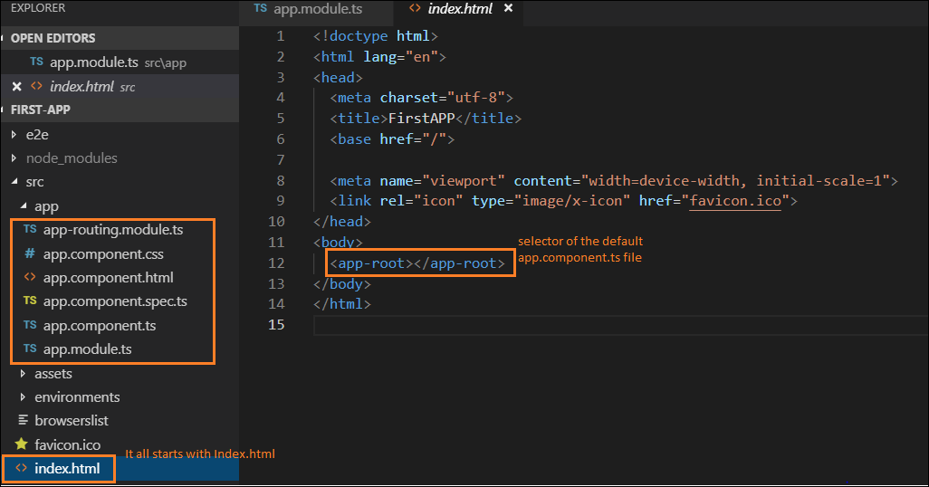

Angular application gets starts from **main.ts** - BootstrapModule starts the Angular application by passing **AppModule** as argument

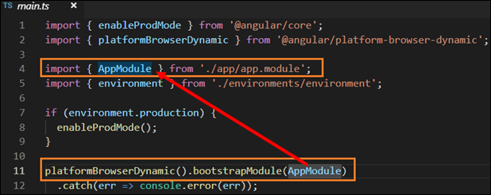

In this **app.module.ts** its checks for **AppComponent** its presented in the Bootstrap array we get this bootstrap array which basically lists all the components

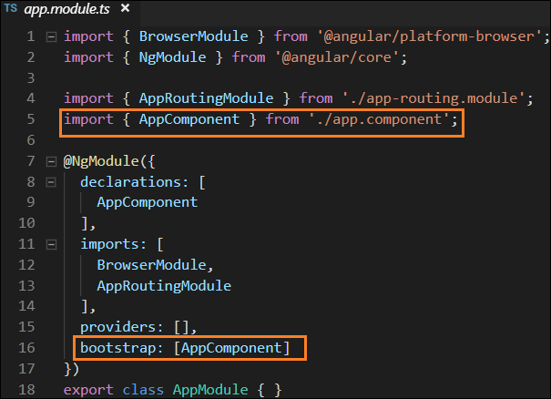

so angular check and analyse the **app.component.ts** and knows the selector **app-root**

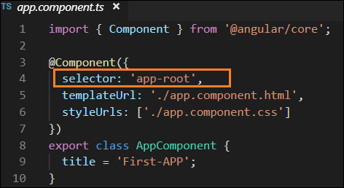

So, Now Angular can able to handle the **app-root** componet in the **index.html** file.